Minutes of the Witney and Woodstock Branch AGM

St Mary the Virgin, Freeland - 7th February 2026, 14:00

Opening Prayer
The opening prayer was led by the Master, Katie Lane.

Attendance Register
Katie Lane, Tony Crabtree, Richard Law, Richard White, Anthony Williamson, Alison Merryweather-Clarke, Michael Probert, Andrew Goldthorpe, Debra Scrimshaw, Jane Burgess, Dana Josephson, Dan Neal, Ruth Leatherdale, Malcom Fairbairn, Susan Shelley, Sue Ross, Zoe White, Simon Powell, Neil Ephgrave, Stephen McLaren, Anne Taylor, Angela Quantrill, Melanie McGregor, Sue Rhodes, Andrew Smith.

Apologies
Meg Roberts, Ian Wilson, Hazel Howarth, Julian Stevens, Liz Stevens, Julie Minch, Geoff Ted, Lindsey Thornton, Jenny Haviland, Andrew Madden, Mel Leggett, Heather Horner, Richard Ford, Nigel Hill, Neil Crossley.

Requests for urgent items of Any Other Business
There were no requests.

Chair's welcome and minutes from 2025 AGM
Andrew Goldthorpe welcomed everyone, thanked Revd Dr Steve Stewart for the service, Guy Reeves for the organ playing, the Freeland band for the refreshments, and thanked members for their attendance.
There was a minute’s silence in memory of Louise Brown of Church Hanborough, David Smith of South Leigh, and Dave Rose of Bampton.
Throughout the year there have been no meetings of the full W&W committee.
There were no comments on the minutes which were approved and signed.
Proposed: Anthony Williamson. Seconded: Richard Law. Carried: Nem con.

Ringing Master Report – Richard White
We have had another steady year in the branch. Saturday morning monthly practices have generally been well supported with the odd exceptions. I am always cheered when local ringers attend and saddened when they do not. The monthly eight bell practices have also continued. Unfortunately, we are unable to hold one at Broadwell because the bells cannot be rung after 7pm.
In April we had a Spring Outing to South Gloucestershire. We rang at Cromhall, Wotton Under Edge, Dursley. Wickwar and finally the lovely new eight at Hawkesbury. Nearly thirty ringers attended and we had some good ringing.
The Branch striking contest was held at Stonesfield in June. Stonesfield ringers provided us with refreshments. I am grateful to Tony Crabtree for judging. Congratulations to Witney for winning the method section and Witney and Church Hanborough for jointly winning the call changes section. Well done to all the towers that participated.
Shilton now has a ring of bells. The augmentation and rehanging was completed late summer and the first quarter was rung on them in October and the first peal just before Christmas. We look forward to ringing on them in the future.
The Autumn outing was held in The Forest of Dean. We rang at Longhope where a scarecrow festival was being held. At the base of the tower was a scarecrow underneath a bell (well, a compost bin). Alison Felton wrote a small article about this for The Ringing World. The Tower Captain also wrote an article about the festival, mentioning our visit. The next stop was Westbury on Severn with its detached tower and heavy six. Following lunch at The Severn Bore we rang at Newnham on Severn, Littledean and finally Newent. Thank you to those who supported both outings during the year and those who ran the ringing which is no easy task.
Freeland requested a ringing up and down practice which was held at Bladon. It was successful and we did a lot of ringing up and down to the point where I could not remember if the bells were up or down.
The Branch was saddened to learn that Dave Rose had died. A greatly respected member of the Branch who was a Guild member over 60 years, he will be greatly missed. Dave’s thanksgiving service was well attended, and all would agree when he was described as the S.O.B.E. (salt of the earth) Our thoughts are with Liz and all the family.
As I travel around the branch, I see all the good work members are doing to keep their towers ringing. It is good to see ringing chambers that are cared for and refurbished.
If you want to get on, join neighbouring practices and Branch Practices. It is important that tower captains highlight and encourage members to support branch events. Your bands, especially new recruits, will take their lead from you. There were twenty-four branch events last year. If you have not been to any then go to one. You will be made most welcome.

Hon. Treasurer Report – Richard Law
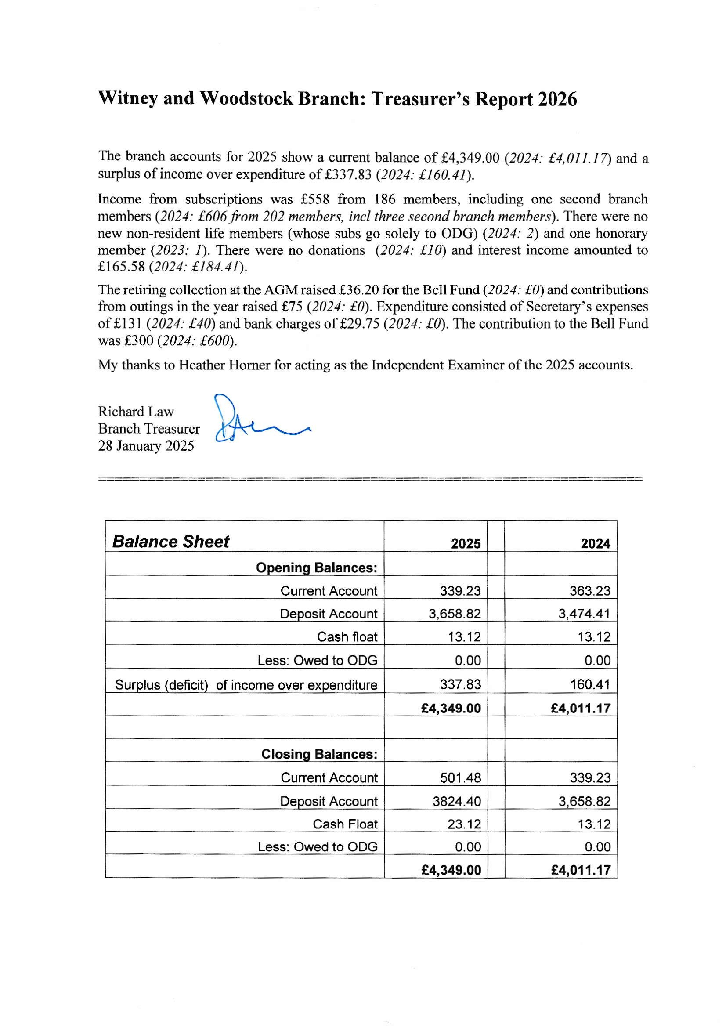

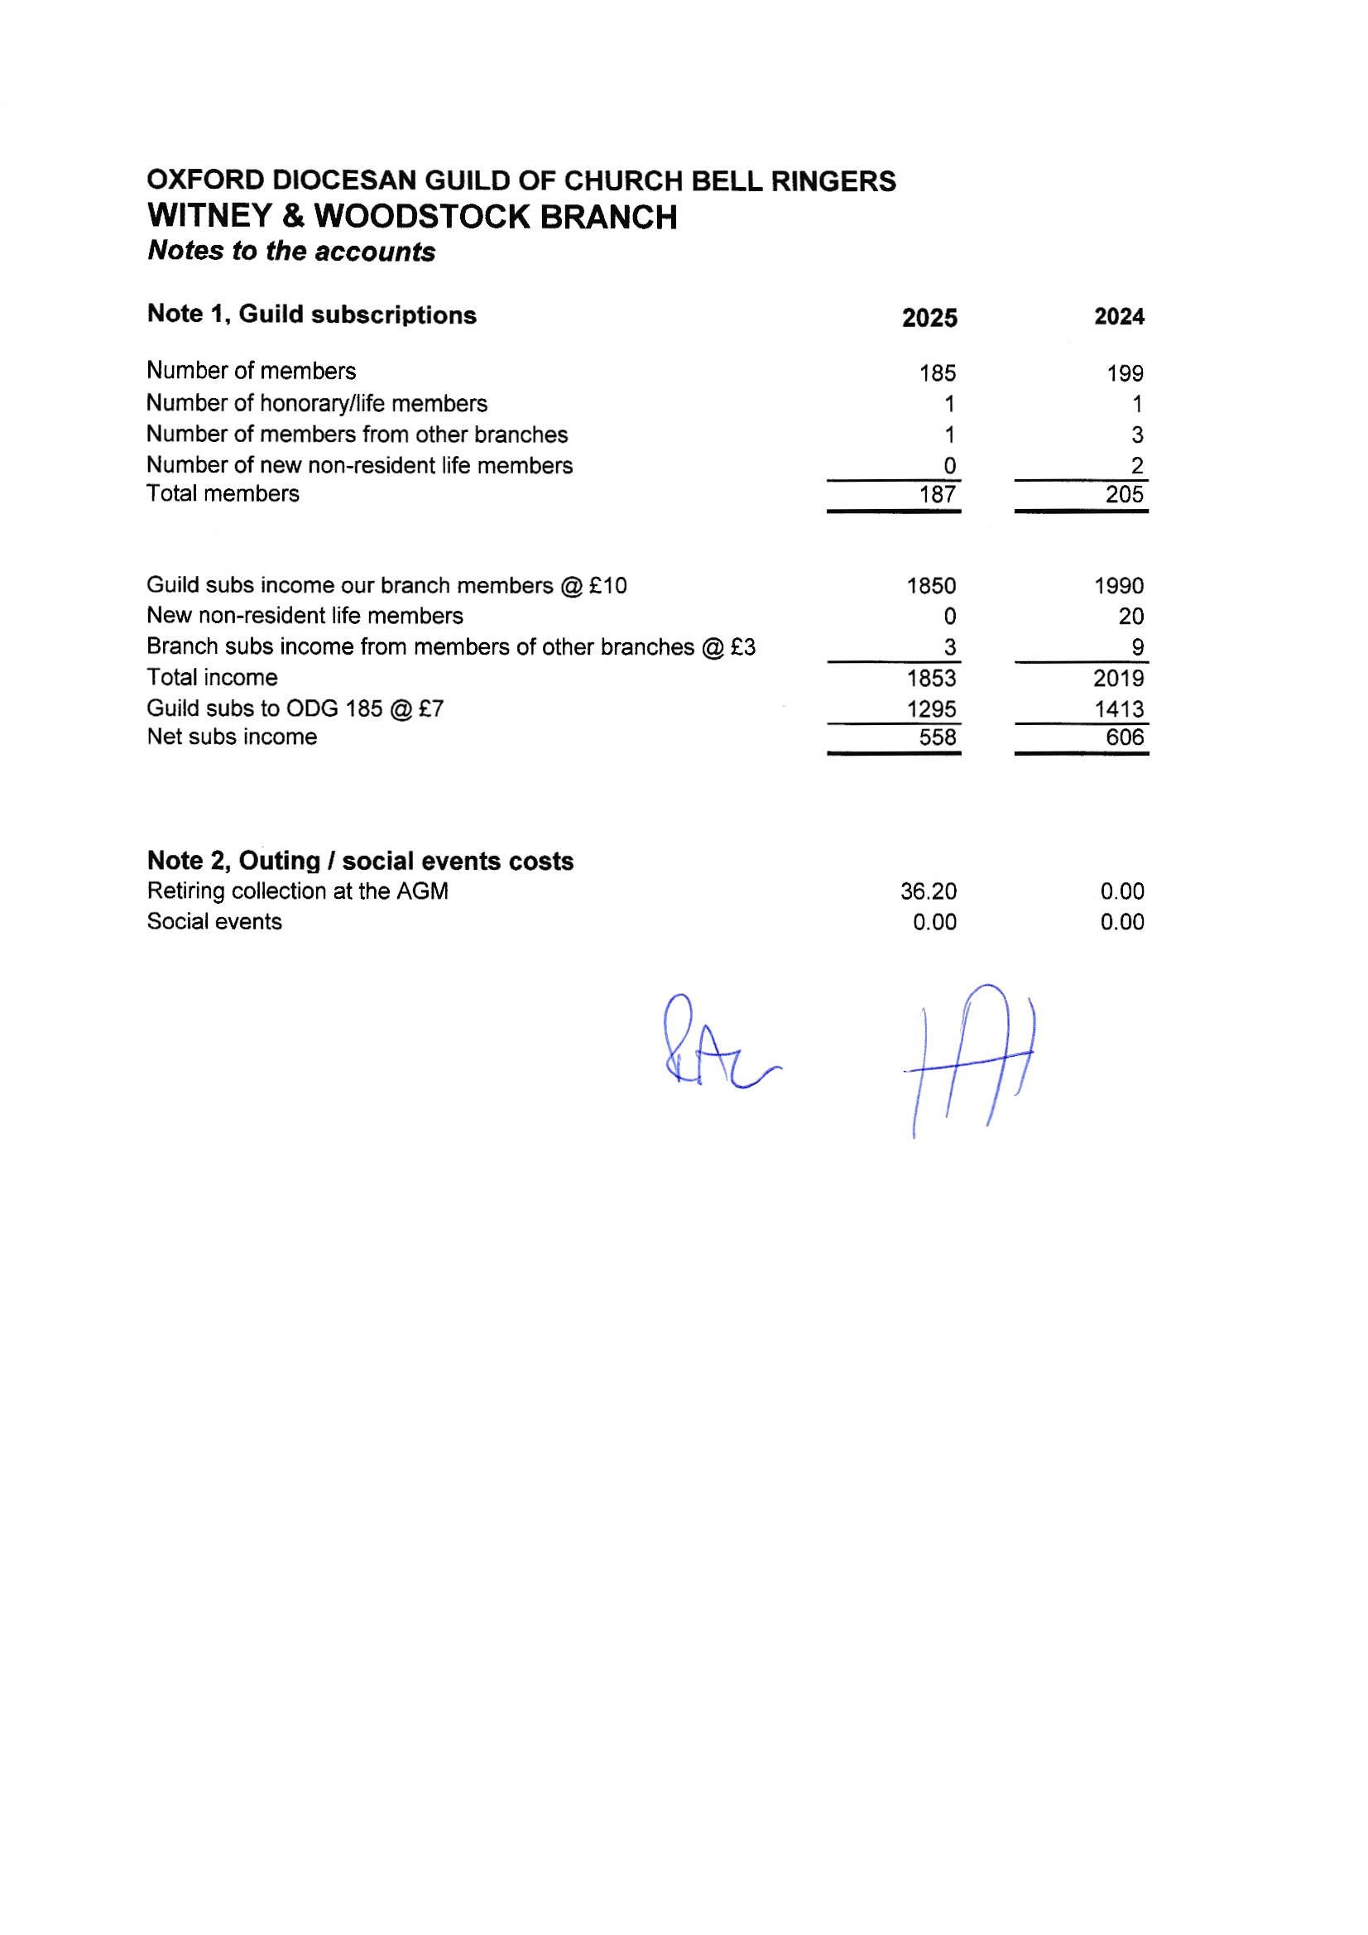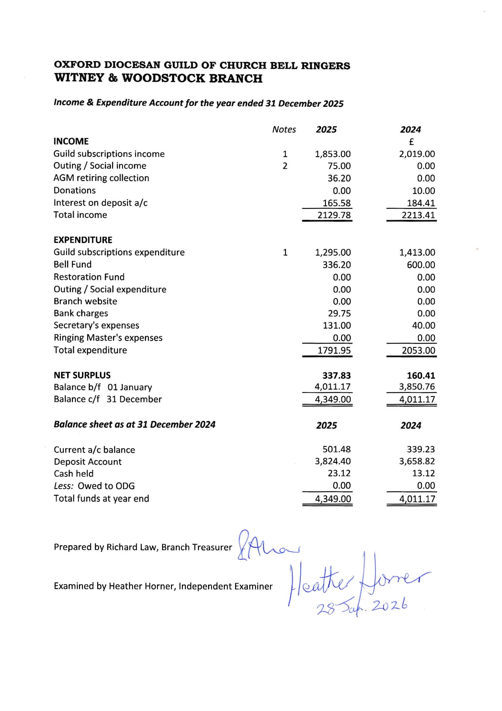
Proposed that the Hon. Secretary’s Report and the Branch Accounts 2025 be accepted: Michael Probert. Seconded: Sue Ross. Carried: Nem con.

Hon. Secretary Report – Andrew Goldthorpe
I start with apologies for the inevitable overlap with the Ringing Master’s report. My role as Branch Secretary involves getting round the Branch as much as I can and getting involved where I can.
I have reproduced my most recent “editor’s” contribution to Odd Bob as the majority of my 2025 Annual Report. It shows some of the many activities I have been involved in or enjoyed hearing about during the year and I am grateful for the assistance, friendships, and contributions from ringers across the Branch.
As the ODG Website Manager, I am also an officer of the Guild, and a member of the F&GP committee, and Membermojo Working Group, so I can represent the views of branch members at ODG committee level should any branch members wish to raise any issues. As part of the F&GP Committee, I have been involved in the drawing up of plans to re-structure the ODG to make it more streamlined and efficient going forwards. You will have received the latest update with the documents circulated for this AGM and a Guild Executive Committee member will say more later.
Thanks to the excellent organisation of Richard White, our Branch Ringing Master, more than twenty members enjoyed our Spring Branch outing to the Gloucestershire area, where a varied set of towers were made available for us and the ringing (rounds, call changes, Plain Hunt Triples, Plain Bob Triples, Stedman Triples, Grandsire Triples, and Cambridge Surprise Minor) catered for a wide range of experience with an enjoyable lunch at the Old Spot in Dursley.
In June, we held our six-bell striking competition with Witney winning the Method competition and coming Joint First with Church Hanborough in the Call Changes competition. This meant that Witney was able to enter the Guild six-bell striking competition in October, the first time a Branch band has entered in several years. We came seventh (out of seven!) and despite there being room for improvement, we all enjoyed the experience and look forward to a Branch band hopefully entering again next year.
Our autumn branch outing visited the Forest of Dean where we rang in five towers with each one being remarkable in its own way. Our less experienced ringers found the experience of handling bells of different weights and rope lengths very useful. The first tower was in the village of Longhope and coincided with their annual scarecrow festival. The second tower, Westbury on Severn, is not attached to the church, as the church had burnt down and been rebuilt to the side of the original church leaving the tower as a freestanding building. Lunch was taken at the Severn Bore, where sadly the bore had appeared the week before, so we missed that, a good reason to go back! We next went to Newnham where the strong glass used in champagne bottles was invented. Then on to Little Dean which was conveniently next to a micro-brewery and café for afternoon tea. Booking recommended and where the fermentation vessels are in the bar area. Finally, we went to Newent, home to the largest unsupported wooden ceiling in the country and trickiest bells of the day in a splendid ringing chamber.
2025 saw the passing of David Smith, former Tower Captain of St James the Great, South Leigh, and an elected Life Member of the ODG. A commemorative peal and quarter peal were rung at South Leigh, and there was a Thanksgiving Service at St Mary’s, Cogges, and afterwards at Cogges Manor Farm.
Louise Brown, a ringer for many years at Church Hanborough and former Branch Ringing Master, passed away in April after a long illness. She was an excellent ringer, known by many, and will be missed by all. A Thanksgiving Service was held at Tackley Crematorium and there was celebratory ringing for the life of Louise at Church Hanborough and Woodstock.

Election of new members
Tower | Member | Proposed | Seconded
NEW MEMBERS
Aston | Justine Manning | Catrin Russ | Ian Russ
Aston | Dave Baxter | Catrin Russ | Ian Russ
Standlake | Michael Pacey | Nigel Hill | Neil Crossley
Woodstock | Victoria Skipper | Malcolm Fairbairn | Ian Wilson
Stanton Harcourt | Janet Jones | Phil Taylor | Jane Eagle
Wootton | Clare Atkins | Mel Leggett | Sue Ross
Stonesfield | Robert Wells | Lindsey Thornton | Jenny Haviland
Stonesfield | Oliver Powell | Lindsey Thornton | Jenny Haviland
Ducklington | Linda Green | Richard Ford | Madeleine Bone
Charlotte Phelps | Freeland | Sue Rhodes | Michael Probert
RE-ELECTED MEMBERS
JUNIOR MEMBERS
Wootton | Oscar Walker | Mel Leggett | Sue Ross

The election of new members was unanimously agreed by those present at the meeting.
ACTION: Hon Secretary to notify ODG Membership Secretary
ACTION: Elected members to create a Membermojo account

Election of Officers
There were the following vacancies on the 2026 Branch Committee:
- Chair – Andrew Goldthorpe is not standing for re-election
- Hon. Secretary – Andrew Goldthorpe is not standing for re-election
- Deputy Secretary – Ruth Leatherdale is standing for re-election
- Hon. Treasurer – Richard Law is standing for re-election
- Ringing Master – Richard White is standing for re-election
- Deputy Ringing Master – Anthony Williamson is not standing for re-election
- Branch Representative – Alison T Merryweather-Clarke is standing for re-election
- Website Manager – Andrew Goldthorpe is not standing for re-election
In the absence of ringing members wishing to fill the vacant positions, several Committee Members agreed to stand for re-election. The members of the 2026 committee are:
Position | Name | Proposed | Seconded
Chair | Andrew Goldthorpe | Richard White | Richard Law
Hon. Treasurer | Richard Law | Alison Merryweather-Clarke | Dana Josephson
Hon. Secretary | Andrew Goldthorpe | Alison Merryweather-Clarke | Dana Josephson
Ringing Master | Richard White | Andrew Goldthorpe | Steve MacLaren
Deputy Ringing Master | Michael Probert | Richard White | Sue Rhodes
Branch Representative | Alison Merryweather-Clarke | Dana Josephson | Richard Law
Branch Spokesperson
Deputy Secretary | Ruth Leatherdale | Richard Law | Richard White
Social Secretary
Health & Safety Officer
Training Officer
Website Manager | Andrew Goldthorpe | Richard Law | Richard White

Proposed: Sue Ross. Seconded: Dana Josephson. Carried: Nem Con.
ACTION: Hon. Secretary to update Server Manager regarding change of Deputy Ringing Master

Items for discussion
- Membermojo (Katie Lane)
  - Tower Captains were reminded to ask new members to create an account for themselves on Membermojo – https://membermojo.co.uk/odg .
  - Members were also reminded of the need to keep their record up to date if their personal circumstances change e.g. change of correspondence details, communication preferences, or tower positions.
  - Note, it is not necessary to log into a Membermojo account every year to keep it live. However, in due course, it is hoped that members will be able to log into their account and pay their annual subscription online. The Guild Secretary will communicate in due course.
- ODG New Structure (Katie Lane)
  - Katie Lane summarised the historical and administrative need to update the operation of the ODG executive.
  - The proposed changes, which were circulated in advance of the AGM, were approved at the Spring General Committee meeting.
  - There was a discussion about the new role of Branch Spokesperson and whether it will be the same as the current Branch Representative position. As the position is part of the planned changes which need to be submitted for approval at the ODG AGM in May, it was agreed that an EGM may need to be called to elect a Branch Spokesperson at a future date.
  - Every member of the ODG is entitled to attend the ODG AGM to be held in North Bucks Branch on Saturday 16th May 2026. To be quorate there need to be 50 members present. To be approved, the proposals need a 75% vote in favour.
  - WWB members are encouraged to feedback any questions to the Master as soon as possible and to attend the AGM and vote in May.
- New member procedure
  - The Hon. Treasurer has already distributed the guidance note with the 2026 request for subscriptions and can be contacted for further copies and guidance.
- Oxford Diocesan Bell Fund Contribution
  - The Master confirmed that the OD Bell Fund received a significant bequest last year, and that the funds are invested in a portfolio.
  - The two previous funds were merged in recent years meaning the fund can take both augmentation and maintenance projects into account when granting funding.
  - WWB towers with specific projects in mind are encouraged to speak to Richard Law in the first instance. It was also noted that the ODG Learning and Development group may be able to grant funding towards tower L&D projects like simulators.
  - In 2025 the Branch voted to donate £300 to the OD Bell Fund, but the Ringing Master proposed that the 2026 donation should be made to the Witney Augmentation Project.
Proposal – donate £300 from WWB funds to the Witney Augmentation project.
Proposed: Richard White, Seconded: Richard Law, Carried New con
ACTION: Hon. Treasurer to transfer £300 to the Witney account with the ODG Treasurer

Branch practices & training
- Ringing Master Honorarium
  - Richard White kindly waived his honorarium
- Ringing calendar
  - All dates have already been circulated by email to branch members with details of Monthly Branch Practices on the second Saturday of the month, 8-bell practices as advertised, and dates for the Spring and Autumn branch outings.
  - All Branch Practices are Saturday 10.30-12.00 and are recorded on Bell Board and the ODG website at https://odg.org.uk/events/
- March 14th BP Broadwell
- April 11th Spring Outing Bedfordshire
- May 9th BP Standlake
- June 13th Striking Contest, Eynsham @ 5pm
- July 11th BP Woodstock
- August 8th BP C Hanborough
- September 12th BP Tackley
- October 10th Autumn Outing
- November 14th BP Shilton
- December 12th BP Bampton
- 8, 10, and 12-bell Practices
  - These are communicated to members by email from the Ringing Master or Hon. Secretary.
- Analysis of Quarter Peals rung during 2025 – Alison Merryweather-Clarke
This report considers 58 QPs posted on BellBoard at http://bb.ringingworld.co.uk/ , rung in tower or hand in 2025, in the Witney and Woodstock branch of the ODG (Table 1). This number is reduced by over 1/3 compared with 2024.
Fifty-six QPs (10 fewer than the previous year) were rung in 20 different towers, and 2 in hand (24 fewer than the previous year) in North Leigh.
Once again, the most prolific QP venue was Witney, with 8 QPs (four Doubles, four Minor, one Triples), a 33% decrease on their 2024 total. These included Churchill Doubles on the 60th anniversary of the death of Sir Winston Churchill, and first QPs of Grandsire Doubles for Ruth Leatherdale and Debra Scrimshaw, first QPs of minor for Dan Neal and Debra Scrimshaw (both achieving LTR level 5), and Amy Thomas’ first QP inside.
Both Woodstock and North Leigh were close behind Witney with 6 QPs apiece, including the first QP for many years by a North Leigh band and Daniel Smith’s 1st QP on 8 at Woodstock. Judith Carr rang her first QP for 40 years in one of 3 QPs at Freeland. The first QP was rung at Shilton, and also the first on Eynsham bells since rehanging.
Twenty QPs (over 30%) referred to a first in the footnote, representing a new achievement and showing that firsts aren’t restricted to Firsts Fortnight!
Equal numbers of Doubles and Minor QPs were rung, accounting for 80% of all QPs. In addition, nine QPs of Triples were rung, and one of Plain Bob Major, in hand. 44 QPs were in a single method, As in 2024, the most commonly rung method was plain bob minor (8 QPs), with 6 QPs of Grandsire Doubles, 6 of Grandsire Triples and 4 of plain bob Doubles.
Quarter peal footnotes celebrated the weddings of Sue Rhodes and John Wilcox, and of Tim Smale and Lucy Welcurn, and of Rev. Dr Hester Jones of St Mary's, Witney, and Mr Andy Sparkes; the 60th birthday of Catrin Russ; the 40th wedding anniversary of Liz and Dave Rose; the births of Daniel and Loki Smith’s first child, and of Freddie Joseph Dixon-Clark, a first grandchild for Zoe and Richard.
In memoriam QPs were rung for John Collett, David Smith, Michael Haynes, Janet Russ, Chris Ward and Zoe Louise Barnett. One QP was rung on St George’s Day, one on Remembrance Sunday, one to mark the 80th anniversary of VJ Day and two to mark the 80th anniversary of VE Day. Two QPs marked the 60th anniversary of the death of Sir Winston Churchill.
Alison was thanked by the committee and attendees for her hard work and detailed analysis.
ACTION: Hon. Secretary to circulate Quarter Peal analysis to all members

Programme for 2026
- Firsts Fortnight
ACTION: Ringing Master to publicise so that certificates can be presented at 6-Bell Striking Contest
- Branch 6-bell striking competition
  - To be held at Eynsham on 13th June 2026.
- Branch social/quiz
  - To be combined with Striking Contest.
- ODG striking competitions
  - Richard White will investigate possibly entering the 8-bell striking competition
- Spring & Autumn Branch outings
  - The Ringing Master has confirmed April 11th for the Spring Outing to Bedfordshire
- Date & venue for 2027 AGM
ACTION: Chair to arrange

Any other business
It was noted that Witney can host 6, 8, 10, and 12 bell simulator practices between 10:00 and 12:00 most Saturday mornings. Please contact Deputy Secretary if interested.

Concluding vote of thanks
The meeting started at 14: 15 and closed at 15:23.

Andrew Goldthorpe, Witney & Woodstock Hon. Secretary
Version 11/02/26

